Text Structure | Explanation | Signal Words |  |  | Graphic Organizers
Cause and Effect | Ideas, events, or facts are presented as causes in conjunction with the resulting outcomes or effect. | - Accordingly  - Consequently  - May be due to  - So  - Thus | - Because  - For this reason  - Nevertheless  - Therefore | - As a result  - If…then  - Since  - This led to | 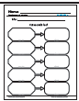
Compare and Contrast | Similarities and differences are presented between two or more topics or concepts. | - Although  - But  - Either…or  - In common  - Similar to | - As opposed to  - Compared with  - Even though  - Likewise  - Yet | - As well as  - Different from  - However  - Not only | 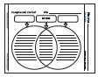
Description | Provides information about a topics | - A number of  - Characteristics  - In addition  - Is like  - To illustrate | - Appears to be  - For example  - In back of  - Looks like | - As in  - For instance  - Including  - Such as | 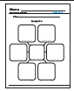
Problem and Solution | Problem is presented followed by one or more solutions. | - A problem  - Because  - In order to  - One reason for  - Steps involved | - A solution  - For this reason  - Leads/led to  - Since  - This led to | - Accordingly  - If…then  - May be due to  - So that  - Thus | 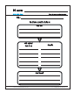
Question and Answer | Question is posed and then followed by answers. | - How  - One may conclude  - When  - Why | - How many  - The best estimate  - Where | - It could be that  - What  - Who | 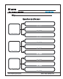
Sequence | Events are described in numerical or chronological order. | - After  - Before  - First  - Initially  - Next  - On (date)  - Soon  - Today  - While | - Afterward  - During  - Following  - Later  - Not long after  - Preceding  - Then  - Until | - At last  - Finally  - Immediately  - Meanwhile  - Now  - Second  - Third  - When | 